EMPLOYEE WEB API – PUT METHOD HANDS-ON
ASP.NET Core Web API using C# and Swagger

1. Aim
To implement and test an HTTP PUT endpoint in an ASP.NET Core Web API for updating employee details, including validation of the employee ID and handling invalid IDs with a 400 Bad Request response.

2. Software / Tools Used
Visual Studio Code, .NET / ASP.NET Core Web API, C#, Swagger (OpenAPI), and a web browser.

3. Project Structure
The EmployeeWebApi project contains the EmployeeController under the Controllers folder and the Employee, Department, and Skill model classes under the Models folder.

4. Model Classes
Employee.cs
namespace EmployeeWebApi.Models
{
public class Employee
{
public int Id { get; set; }
public string Name { get; set; } = string.Empty;
public int Salary { get; set; }
public bool Permanent { get; set; }
public Department? Department { get; set; }
public List<Skill> Skills { get; set; } = new();
public DateTime DateOfBirth { get; set; }
}
}
Department.cs
namespace EmployeeWebApi.Models
{
public class Department
{
public int Id { get; set; }
public string Name { get; set; } = string.Empty;
}
}
Skill.cs
namespace EmployeeWebApi.Models
{
public class Skill
{
public int Id { get; set; }
public string Name { get; set; } = string.Empty;
}
}

5. EmployeeController.cs
EmployeeController.cs
using Microsoft.AspNetCore.Authorization;
using Microsoft.AspNetCore.Mvc;
using EmployeeWebApi.Models;
namespace EmployeeWebApi.Controllers
{
[ApiController]
[Route("api/[controller]")]
public class EmployeeController : ControllerBase
{
private List<Employee> GetStandardEmployeeList()
{
return new List<Employee>
{
new Employee
{
Id = 1,
Name = "John",
Salary = 50000,
Permanent = true,
Department = new Department { Id = 1, Name = "IT" },
Skills = new List<Skill>
{
new Skill { Id = 1, Name = "C#" },
new Skill { Id = 2, Name = "ASP.NET Core" }
},
DateOfBirth = new DateTime(2000, 5, 10)
},
new Employee
{
Id = 2,
Name = "Alice",
Salary = 45000,
Permanent = false,
Department = new Department { Id = 2, Name = "HR" },
Skills = new List<Skill>
{
new Skill { Id = 3, Name = "Communication" }
},
DateOfBirth = new DateTime(1999, 8, 15)
}
};
}
[AllowAnonymous]
[HttpGet]
[ProducesResponseType(typeof(List<Employee>), StatusCodes.Status200OK)]
public ActionResult<List<Employee>> Get()
{
return Ok(GetStandardEmployeeList());
}
[HttpGet("standard")]
[ProducesResponseType(typeof(Employee), StatusCodes.Status200OK)]
public ActionResult<Employee> GetStandard()
{
return Ok(GetStandardEmployeeList().First());
}
[HttpPost]
[ProducesResponseType(typeof(Employee), StatusCodes.Status200OK)]
public ActionResult<Employee> Post([FromBody] Employee employee)
{
return Ok(employee);
}
[HttpPut("{id}")]
[ProducesResponseType(typeof(Employee), StatusCodes.Status200OK)]
[ProducesResponseType(StatusCodes.Status400BadRequest)]
public ActionResult<Employee> Put(int id, [FromBody] Employee employee)
{
if (id <= 0)
return BadRequest("Invalid employee id");
var existingEmployee = GetStandardEmployeeList()
.FirstOrDefault(e => e.Id == id);
if (existingEmployee == null)
return BadRequest("Invalid employee id");
employee.Id = id;
return Ok(employee);
}
}
}

6. Program.cs
Program.cs
var builder = WebApplication.CreateBuilder(args);
builder.Services.AddControllers();
builder.Services.AddEndpointsApiExplorer();
builder.Services.AddSwaggerGen();
var app = builder.Build();
if (app.Environment.IsDevelopment())
{
app.UseSwagger();
app.UseSwaggerUI();
}
app.UseHttpsRedirection();
app.UseAuthorization();
app.MapControllers();
app.Run();

7. Build and Run
The project was built using the dotnet build command. After terminating the previously running process that had locked the executable, the build completed successfully. The API was then started using dotnet run and listened on localhost port 5027.

8. Execution Screenshots
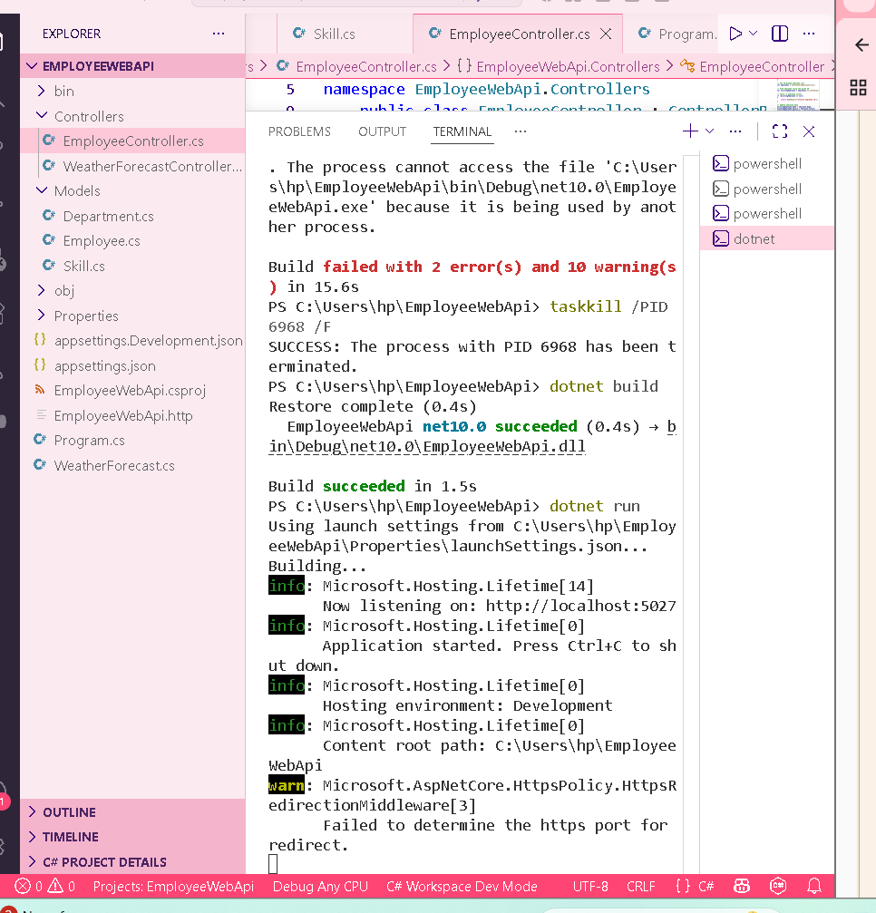
Figure 1: Successful build and execution of EmployeeWebApi in the VS Code terminal.
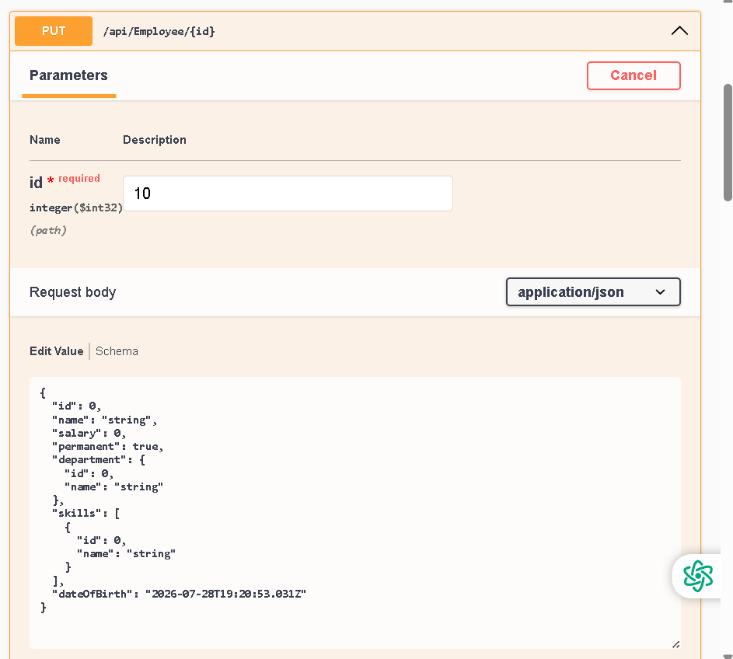
Figure 2: Swagger PUT request for /api/Employee/{id} with employee ID 10.
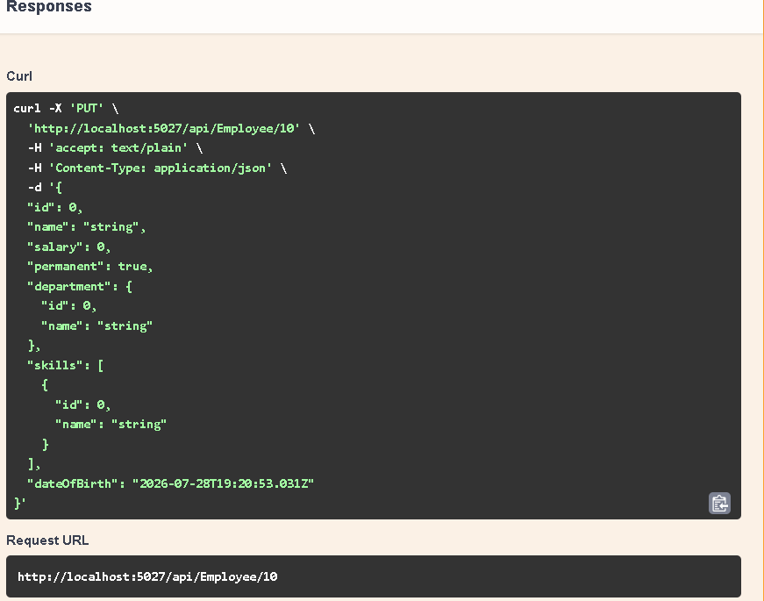
Figure 3: PUT request generated by Swagger for /api/Employee/10.
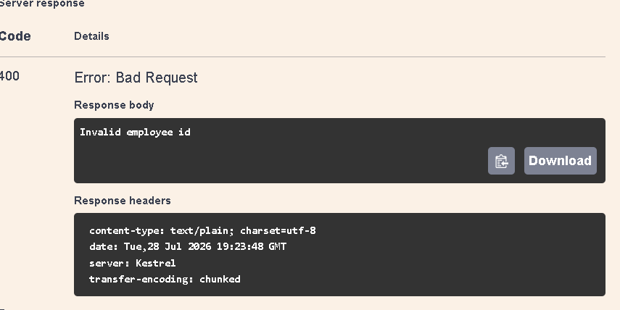
Figure 4: Server response – HTTP 400 Bad Request with the message “Invalid employee id”.

9. Test Result
The PUT endpoint was tested with employee ID 10. Since ID 10 is not present in the hardcoded employee list, the API correctly returned HTTP status code 400 (Bad Request) with the response body: “Invalid employee id”. This confirms that invalid employee IDs are handled by the API.

10. Result / Conclusion
The Employee Web API PUT operation was implemented and tested successfully. The API accepts employee data through the request body, validates the ID supplied in the route, returns the updated employee for a valid existing ID, and returns 400 Bad Request for an invalid or non-existing employee ID. Swagger was used to verify the endpoint behavior.

